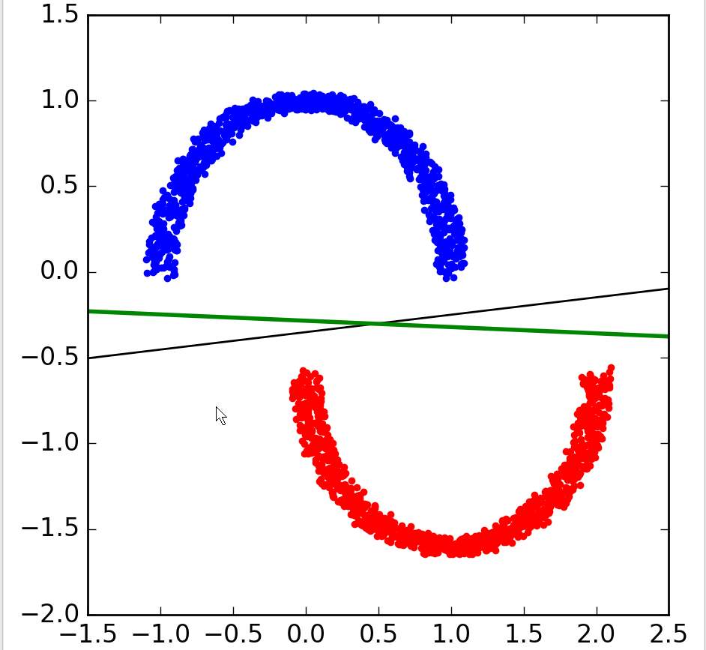

The modified PLA took 5 iterations to find a hypothesis for these semi circles. Each iteration took a rather extended amount of time but that might be due to my relatively old/slow CPU. Since the two circle are made to be linearly separable and there is a large amount of space between them it didn’t take the perceptron many iterations to find a single hypothesis that divided the points.

